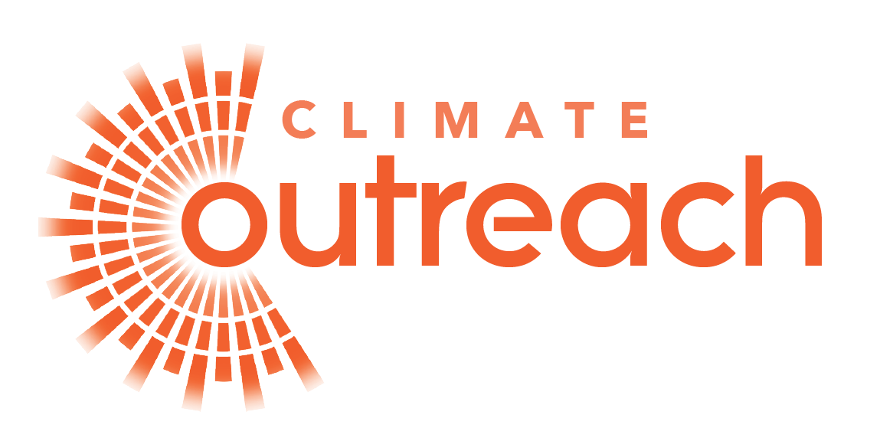

DIVERSITY, EQUALITY & INCLUSION MONITORING INFORMATION

The following information is collected as part of our commitment towards achieving equality of opportunity in our employment practices. The information you provide is confidential and will be removed from the application form upon receipt and will not form part of your application.

You are not obliged to answer any of the questions, but you will appreciate that, for our monitoring policy to be wholly effective, we should hope to have 100% response. If you do not wish to answer any question(s), this will not affect your application. All questions on this form relate to protected characteristics under Equality Act 2010 section 4.

Please don’t write your name on this form.

1. Post applied for:

2. How do you describe your gender:

3. Do you identify as trans?:

Yes/No

Note: Trans is an umbrella term people whose identity differs from what is typically associated with the sex they were assigned at birth. People under the trans umbrella may describe themselves using one or more of a wide variety of terms – including transgender. (definition by Stonewall.org)

4. Age (please put an ‘x’ in the correct box):

16 - 24
25 - 34
35 - 44
45 - 54
55 - 64
65+

5. What is your ethnicity?
We appreciate that some people, including those of mixed race, may not be happy with the classifications used on equality monitoring forms. The classifications below are those currently recommended by the Commission for Racial Equality. If you wish to classify yourself in some other way, please use the additional space provided to do so.
A: WHITE  British  English  Scottish  Welsh  Northern Irish  Irish Traveller  Any other White background  ……………… | •  •  •  •  •  •  • |  | B: MIXED  White & Black Caribbean  White & Black African  White & Asian  Any other Mixed background  ……………… | •  •  •  •
C: ASIAN, ASIAN BRITISH, ASIAN SCOTTISH, ASIAN WELSH OR ASIAN NORTHERN IRISH  Indian  Pakistani  Bangladeshi  Any other Asian background  ……………… | •  •  •  • |  | D: BLACK, BLACK BRITISH, BLACK ENGLISH, BLACK SCOTTISH, BLACK WELSH OR BLACK NORTHERN IRISH  Caribbean  African  Any other Black background  ……………… | •  •  •
E: CHINESE, CHINESE BRITISH, CHINESE SCOTTISH, CHINESE WELSH OR CHINESE NORTHERN IRISH  Any other Chinese background  ……………… | • |  | F: OTHER ETHNIC GROUP  Arab  Any other Arab background  ……………… | •  •
6. Are you married / in a civil partnership / in a committed relationship / not with a partner / other

………………
7. How do you describe your sexual orientation?
- Bi
- Gay/Lesbian
- Heterosexual/ Straight
- Self describe:
………………
8. Do you consider yourself to have a disability? If yes, please provide details of your disability.

Yes / No

